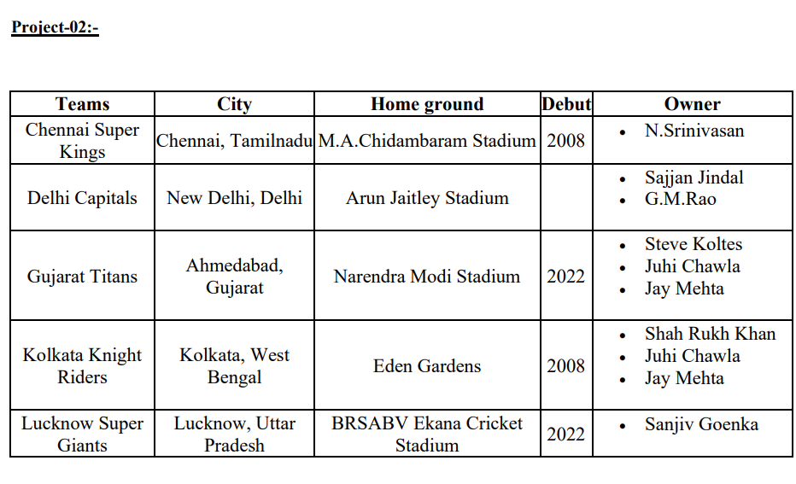

**Answer**:

<!DOCTYPE html>

<html>

<head>

<tilte></tilte>

</head>

<body>

<div>

<table border="">

<tr>

<th>Teams</th>

<th>City</th>

<th>Home ground</th>

<th>Deput</th>

<th>Owner</th>

</tr>

<tr>

<th>Chennai Super Kings</th>

<th>Chennai, Tamilnadu</th>

<th>M.A.Chidambaram Stadium</th>

<th>2008</th>

<th><ul type="disc">

<li>N.Srinivasan</li>

</ul>

</th>

</tr>

<tr>

<th>Delhi Capitals</th>

<th>New Delhi, Delhi</th>

<th>Arun Jaitly Stadium</th>

<th></th>

<th><ul type="disc">

<li>Sajjan Jindal</li>

<li>G.M.Rao</li>

</ul>

</th>

</tr>

<tr>

<th>Gujarat Titans</th>

<th>Ahmedabad, Gujarat</th>

<th>Narendra Modi Stadium</th>

<th>2022</th>

<th><ul type="disc">

<li>Steve Koltes</li>

<li>Juhi Chawla</li>

<li>Jay Mehta</li>

</ul>

</th>

</tr>

<tr>

<th>Kolkata Knight Riders</th>

<th>Kolkata, West Bengal</th>

<th>Eden Gardens</th>

<th>2008</th>

<th><ul type="disc">

<li>Shah Rukh Khan</li>

<li>Juhi Chawla</li>

<li>Jay Mehta</li>

</ul>

</th>

</tr>

<tr>

<th>Lucknow Super Giants</th>

<th>Lucknow, UttarPradesh</th>

<th>BRSABV Ekana Cricket Stadium</th>

<th>2022</th>

<th><ul type="disc">

<li>Sanjiv Goenka</li>

</ul>

</th>

</tr>

</table>

</div>

</body>

</html>